The Islamia University of Bahawalpur
Faculty of computing
Department of Information Technology

Project Software Design Description (SDD)
For

AI-Powered Multi-Courier Dropshipping System
Submitted By
Muhammad Shahzad
S23BINFT1M01133

Session SPRING 2023 – 2027

Supervisor
Prof. Dr Mustafa Hameed

1. Introduction

1.1 Purpose
This Software Design Document provides the technical design specifications for the AI-Powered Multi-Courier Dropshipping System.

1.2 Scope
This document covers system architecture, database design, API specifications, component design, security design, and user interface guidelines.

1.3 Use Case Diagram

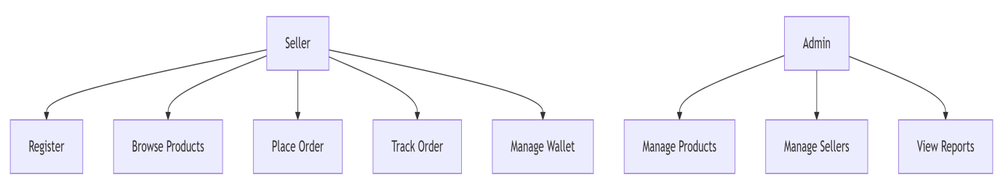

2. Technology Stack

Layer | Technology | Version | Purpose
Frontend | Next.js | 14.x | React framework with SSR
Frontend | Tailwind CSS | 3.x | Styling
Frontend | Redux Toolkit | 2.x | State management
Backend | NestJS | 10.x | API framework
Backend | Node.js | 20.x | Runtime
AI/ML | Python | 3.11 | AI service
AI/ML | FastAPI | 0.104 | AI API framework
Database | PostgreSQL | 15.x | Primary database
Database | Redis | 7.x | Cache and queues
Database | Elasticsearch | 8.x | Search engine
DevOps | Docker | 24.x | Containerization

3. System Architecture

3.1 Architecture Layers

Layer | Components | Technology
Client Layer | Web Application | Next.js 14
API Gateway | Request routing, Authentication | NestJS + Nginx
Microservices | Auth, Product, Order, Wallet, Courier, AI | Node.js, Python
Cache Layer | Session storage, Rate limiting | Redis 7
Database Layer | Primary data storage | PostgreSQL 15
Search Layer | Product search | Elasticsearch 8
Storage Layer | Images, Labels | AWS S3 / MinIO

3.2 Service Ports

Service | Port | Protocol
Nginx Reverse Proxy | 80, 443 | HTTP/HTTPS
API Gateway | 3001 | HTTP
Auth Service | 3002 | HTTP
Product Service | 3003 | HTTP
Order Service | 3004 | HTTP
Wallet Service | 3005 | HTTP
Courier Service | 3006 | HTTP
AI Service | 5000 | HTTP
Notification Service | 3007 | HTTP
PostgreSQL | 5432 | TCP
Redis | 6379 | TCP
Elasticsearch | 9200 | HTTP

3.3 System Architecture Diagram
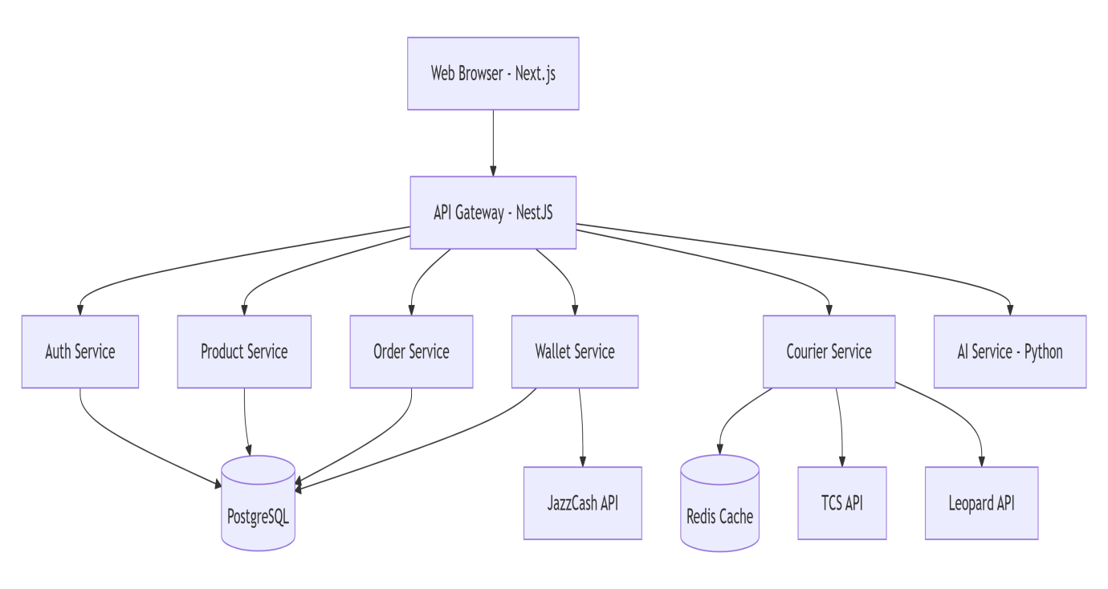

4. Database Design

4.1 Database ER Diagram (Entity Relationship)

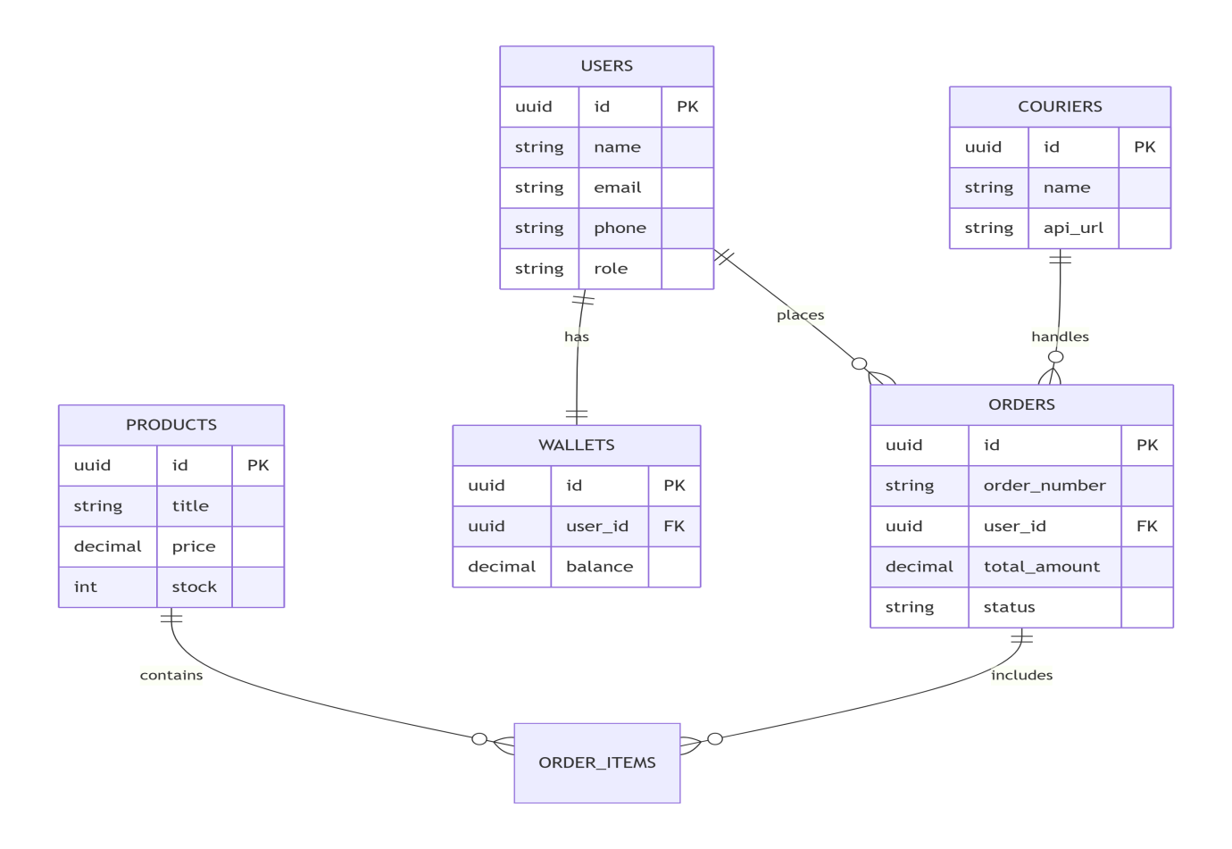

4.2 Main Entities

Entity | Description | Key Fields
users | Seller and admin accounts | id, name, email, phone, cnic, role
products | Product catalog | id, title, price, stock, category_id
categories | Product categories | id, name, parent_id
orders | Order details | id, order_number, user_id, total_amount
order_items | Items within orders | order_id, product_id, quantity
wallets | Seller wallet balances | user_id, balance
transactions | Payment history | wallet_id, amount, type
couriers | Courier service config | id, name, api_url, is_active
shipping_rates | Dynamic shipping rates | courier_id, origin, destination, rate
tracking_updates | Shipment tracking | order_id, status, location
reviews | Product ratings | product_id, user_id, rating
notifications | User alerts | user_id, title, message
ad_campaigns | Social media ads | user_id, product_id, budget

4.3 Users Table Schema

Column | Type | Constraint
id | UUID | Primary Key
name | VARCHAR(100) | Not Null
email | VARCHAR(100) | Unique, Not Null
phone | VARCHAR(15) | Unique, Not Null
cnic | VARCHAR(15) | Unique, Not Null
password_hash | TEXT | Not Null
role | VARCHAR(20) | Default 'seller'
verification_status | VARCHAR(20) | Default 'pending'
created_at | TIMESTAMP | Default Current Timestamp
updated_at | TIMESTAMP | Default Current Timestamp

4.4 Products Table Schema

Column | Type | Constraint
id | UUID | Primary Key
title | VARCHAR(200) | Not Null
description | TEXT | -
price | DECIMAL(10,2) | Not Null
stock | INT | Not Null, Default 0
sku | VARCHAR(50) | Unique, Not Null
category_id | UUID | Foreign Key
images | TEXT[] | -
rating | FLOAT | Default 0
total_reviews | INT | Default 0
created_at | TIMESTAMP | Default Current Timestamp
updated_at | TIMESTAMP | Default Current Timestamp

4.5 Orders Table Schema

Column | Type | Constraint
id | UUID | Primary Key
order_number | VARCHAR(20) | Unique, Not Null
user_id | UUID | Foreign Key to users
subtotal | DECIMAL(10,2) | Not Null
shipping_cost | DECIMAL(10,2) | Default 0
total_amount | DECIMAL(10,2) | Not Null
payment_method | VARCHAR(20) | -
payment_status | VARCHAR(20) | Default 'pending'
order_status | VARCHAR(20) | Default 'pending'
courier_id | UUID | Foreign Key to couriers
tracking_id | VARCHAR(100) | -
shipping_address | TEXT | Not Null
placed_at | TIMESTAMP | Default Current Timestamp
shipped_at | TIMESTAMP | -
delivered_at | TIMESTAMP | -

4.6 Wallets Table Schema

Column | Type | Constraint
id | UUID | Primary Key
user_id | UUID | Unique, Foreign Key
balance | DECIMAL(12,2) | Default 0
pending_balance | DECIMAL(12,2) | Default 0
created_at | TIMESTAMP | Default Current Timestamp

4.7 Database Indexes

Index Name | On Column | Purpose
idx_users_email | users(email) | Fast login by email
idx_users_phone | users(phone) | Fast login by phone
idx_orders_user_id | orders(user_id) | Fast user orders query
idx_orders_order_status | orders(order_status) | Fast status filter
idx_products_category_id | products(category_id) | Fast category filter
idx_transactions_wallet_id | transactions(wallet_id) | Fast wallet history

5. API Design

5.1 API Convention

Aspect | Standard
Base URL | https://api.dropshipping.com/api/v1
Format | JSON
Authentication | Bearer JWT Token
Date Format | ISO 8601
Pagination | page=1&limit=20

5.2 Authentication Endpoints

Method | Endpoint | Description | Auth Required
POST | /auth/register | Seller registration | No
POST | /auth/verify-otp | Verify OTP code | No
POST | /auth/login | Login | No
POST | /auth/logout | Logout | Yes
POST | /auth/forgot-password | Request password reset | No
POST | /auth/reset-password | Reset password | No
GET | /auth/me | Get current user | Yes

5.3 Product Endpoints

Method | Endpoint | Description | Auth Required
GET | /products | Get all products | Yes
GET | /products/:id | Get product by ID | Yes
GET | /products/search | Search products | Yes
GET | /products/category/:categoryId | Get products by category | Yes
POST | /products | Create product | Admin only
PUT | /products/:id | Update product | Admin only
DELETE | /products/:id | Delete product | Admin only

5.4 Order Endpoints

Method | Endpoint | Description | Auth Required
POST | /orders | Create order | Yes
GET | /orders | Get user orders | Yes
GET | /orders/:id | Get order details | Yes
PUT | /orders/:id/cancel | Cancel order | Yes
GET | /orders/:id/track | Track order | Yes
PUT | /orders/:id/status | Update status | Admin only

5.5 Order Activity Diagram

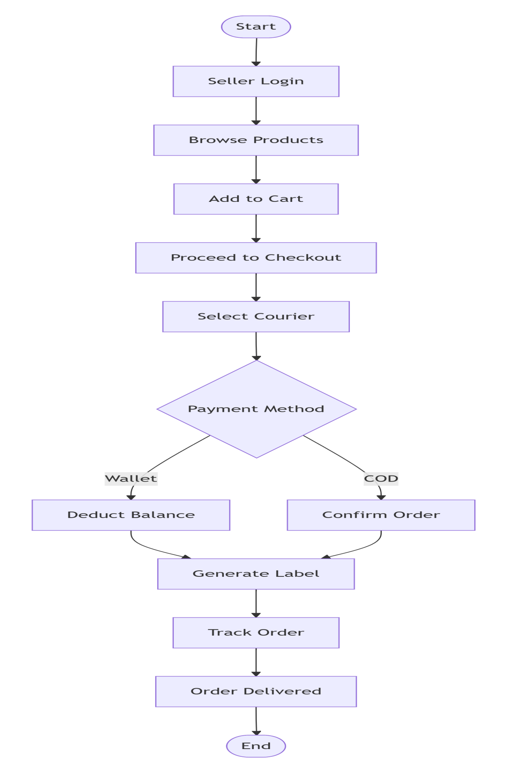

5.6 Wallet Endpoints

Method | Endpoint | Description | Auth Required
GET | /wallet/balance | Get wallet balance | Yes
POST | /wallet/deposit | Deposit funds | Yes
POST | /wallet/withdraw | Withdraw funds | Yes (2FA)
GET | /wallet/transactions | Get transaction history | Yes
POST | /wallet/pay | Pay for order | Yes

5.7 Courier Endpoints

Method | Endpoint | Description | Auth Required
GET | /courier/rates | Get shipping rates | Yes
POST | /courier/label | Generate shipping label | Yes
GET | /courier/track/:trackingId | Track shipment | Yes
GET | /courier/recommend | AI recommendation | Yes

5.8 API Request and Response Examples
Register Request:
- Endpoint: POST /api/v1/auth/register
- Body: { "name": "Ahmed Khan", "email": "ahmed@example.com", "phone": "03001234567", "cnic": "12345-1234567-1", "password": "SecurePass123" }

Register Response:
- Body: { "success": true, "message": "OTP sent to your phone", "data": { "userId": "550e8400-e29b-41d4-a716-446655440000", "otpExpiresIn": 300 } }

Login Request:
- Endpoint: POST /api/v1/auth/login
- Body: { "email": "ahmed@example.com", "password": "SecurePass123" }

Login Response:
- Body: { "success": true, "data": { "accessToken": "eyJhbGciOiJIUzI1NiIs...", "expiresIn": 3600, "user": { "id": "uuid", "name": "Ahmed Khan", "email": "ahmed@example.com", "role": "seller" } } }

Create Order Request:
- Endpoint: POST /api/v1/orders
- Body: { "items": [ { "productId": "product-1", "quantity": 2 } ], "courierId": "courier-001", "paymentMethod": "wallet", "shippingAddress": { "fullName": "Ahmed Khan", "city": "Lahore", "phone": "03001234567" } }

Create Order Response:
- Body: { "success": true, "data": { "orderId": "order-001", "orderNumber": "ORD-001234", "totalAmount": 5200, "status": "confirmed", "createdAt": "2026-04-01T10:30:00Z" } }

Get Courier Rates Response:
- Endpoint: GET /api/v1/courier/rates?city=Lahore&weight=2
- Body: { "success": true, "data": { "rates": [ { "courierName": "TCS", "rate": 250, "days": 2 }, { "courierName": "Leopard", "rate": 180, "days": 3 } ], "aiRecommendation": { "recommended": "Leopard", "reason": "Cheapest option" } } }

5.9 Error Response Format

Field | Description
success | false
error.code | Error code like VALIDATION_ERROR
error.message | Human readable error message
error.statusCode | HTTP status code like 400
error.timestamp | ISO timestamp of error

5.10 HTTP Status Codes

Status Code | Meaning
200 | Success
201 | Created
400 | Bad Request
401 | Unauthorized
403 | Forbidden
404 | Not Found
429 | Too Many Requests
500 | Internal Server Error

5.11 Order Processing API Flow Diagram

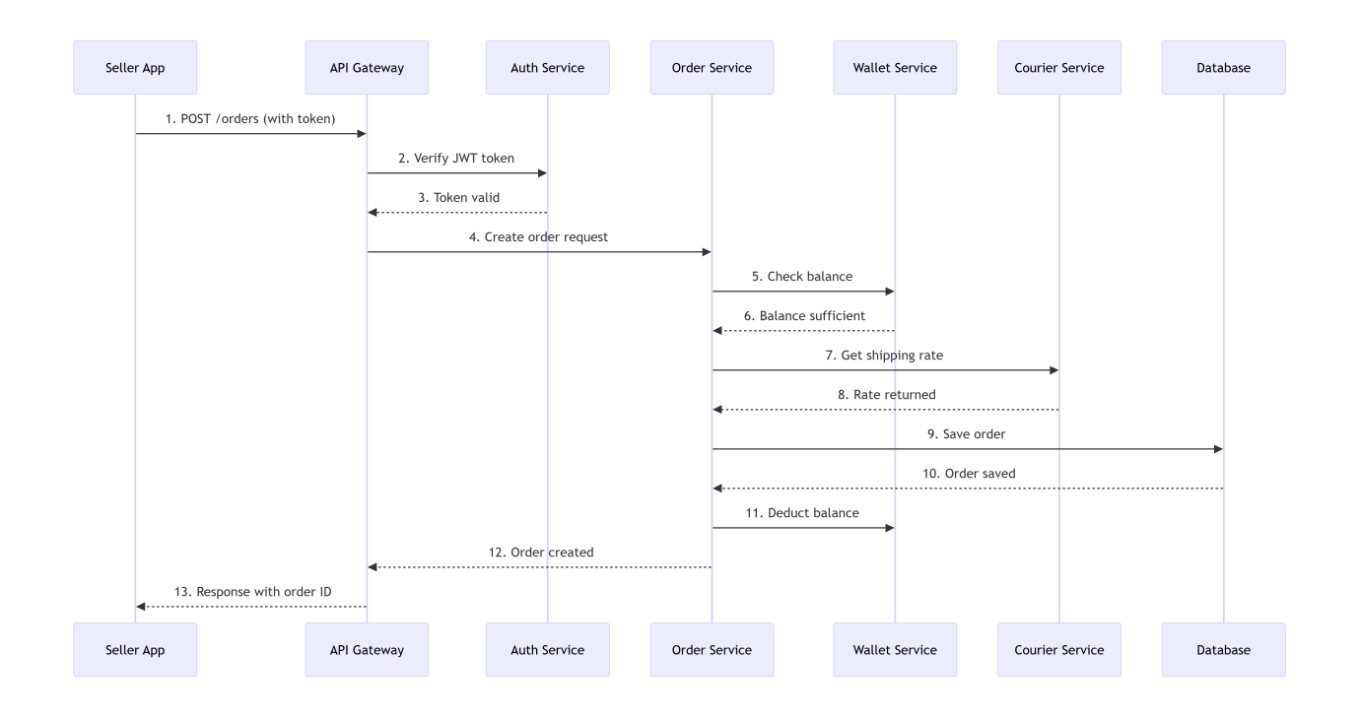

6. Security Design

6.1 Security Measures

Security Aspect | Implementation
Authentication | JWT with 1 hour expiry
Password Storage | bcrypt with salt rounds 12
API Security | Rate limiting 100 requests per minute
Wallet Security | 2FA mandatory for withdrawals
Data Encryption | AES-256 for sensitive data
HTTPS | TLS 1.3 enabled
Input Validation | Joi schema validation
SQL Injection | Parameterized queries

6.2 Environment Variables

Variable | Purpose
DATABASE_URL | PostgreSQL connection string
REDIS_URL | Redis connection string
JWT_SECRET | JWT signing secret
JWT_EXPIRY | Token expiry in seconds
JAZZCASH_MERCHANT_ID | JazzCash merchant ID
TCS_API_KEY | TCS API authentication key
LEOPARD_API_KEY | Leopard API authentication key
FACEBOOK_APP_ID | Facebook ad API app ID

7. External Integrations

7.1 Courier APIs

Courier | Base URL | Authentication
TCS | https://api.tcs.com.pk/v1 | API Key
Leopard | https://api.leopard.pk/v2 | Bearer Token
MNP | https://api.mnp.com.pk/api | API Key + Secret

7.2 Payment Gateways

Gateway | Integration Type | Purpose
JazzCash | REST API | Wallet deposits and withdrawals
Easypaisa | REST API | Wallet deposits and withdrawals

7.3 Social Media APIs

Platform | API | Purpose
Facebook | Business Manager API | Ad creation and management
TikTok | Ads API | Ad creation and management

8. Frontend Components

8.1 Component List

Component | Description
Navbar | Top navigation bar
Sidebar | Side menu for seller
ProductCard | Displays product summary
ProductDetail | Full product view
CartDrawer | Shopping cart sidebar
CheckoutForm | Order checkout form
CourierSelector | Courier selection UI
PaymentMethod | Payment method selection
OrderTracking | Real-time tracking display
WalletBalance | Wallet balance display
TransactionHistory | Transaction list
RatingStars | Star rating input
AnalyticsChart | Sales visualization
AdBooster | Ad campaign creator
NegotiationChat | Price negotiation chat
NotificationBell | Notification dropdown

8.2 Page Routes

Route | Page | Description
/ | Home | Landing page
/products | Products | Product listing
/products/:id | ProductDetail | Product details
/cart | Cart | Shopping cart
/checkout | Checkout | Order checkout
/orders | Orders | Order history
/orders/:id/track | Tracking | Order tracking
/dashboard | Dashboard | Seller dashboard
/wallet | Wallet | Wallet management
/analytics | Analytics | Sales analytics
/marketing | Marketing | Ad boosting
/profile | Profile | User profile
/login | Login | Login page
/register | Register | Registration page

8.3 Order Status Lifecycle Diagram
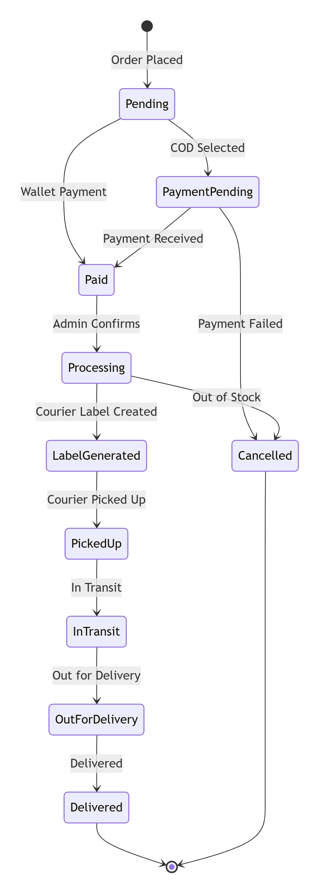

9. Deployment

9.1 Environments

Environment | URL | Purpose
Development | http://localhost:3000 | Local development
Staging | https://staging.dropshipping.com | QA testing
Production | https://dropshipping.com | Live system

9.2 Deployment Pipeline Stages

Stage | Actions
Code Push | Developer pushes code to GitHub
Build | Install dependencies, run tests
Docker Build | Create container images
Push Registry | Push to Docker registry
Deploy | Deploy to production server

9.2 Deployment Architecture Diagram

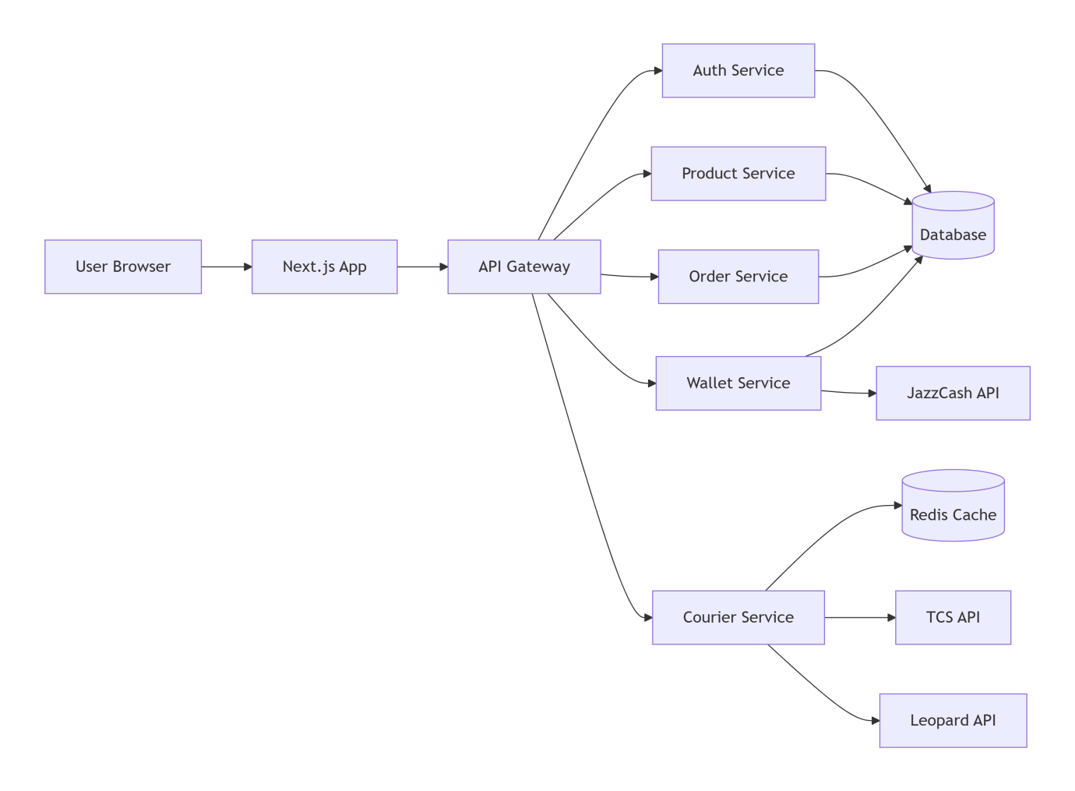

10. Testing Strategy

10.1 Testing Levels

Level | Tools | Coverage Target
Unit Testing | Jest, pytest | 80 percent
Integration Testing | Supertest | 70 percent
E2E Testing | Cypress | Critical paths
Performance Testing | k6 | 1000 concurrent users

10.2 Test Cases Summary

Module | Unit Tests | Integration Tests
Authentication | 15 | 8
Products | 20 | 10
Orders | 25 | 12
Wallet | 20 | 10
Courier | 15 | 8

11. Performance Requirements

Requirement | Target
Page Load Time | Less than 2 seconds
API Response Time | Less than 500 milliseconds
Concurrent Users | 500+ users
Order Processing Time | Less than 3 seconds
AI Recommendation Time | Less than 1 second
System Uptime | 99.9 percent

Section 12: Error Handling Strategy

12.1 Error Types
Validation errors, authentication errors, business logic errors, and system errors will be handled separately.

12.2 Retry Policy
Courier API will retry 3 times, payment gateway will retry 2 times, then fallback to manual review.

Section 13: Logging and Monitoring

13.1 Log Levels
ERROR, WARN, INFO, and DEBUG logs will be maintained for all system events.

13.2 Monitoring Metrics
API response time, error rate, CPU usage, and database connections will be monitored with alerts.

